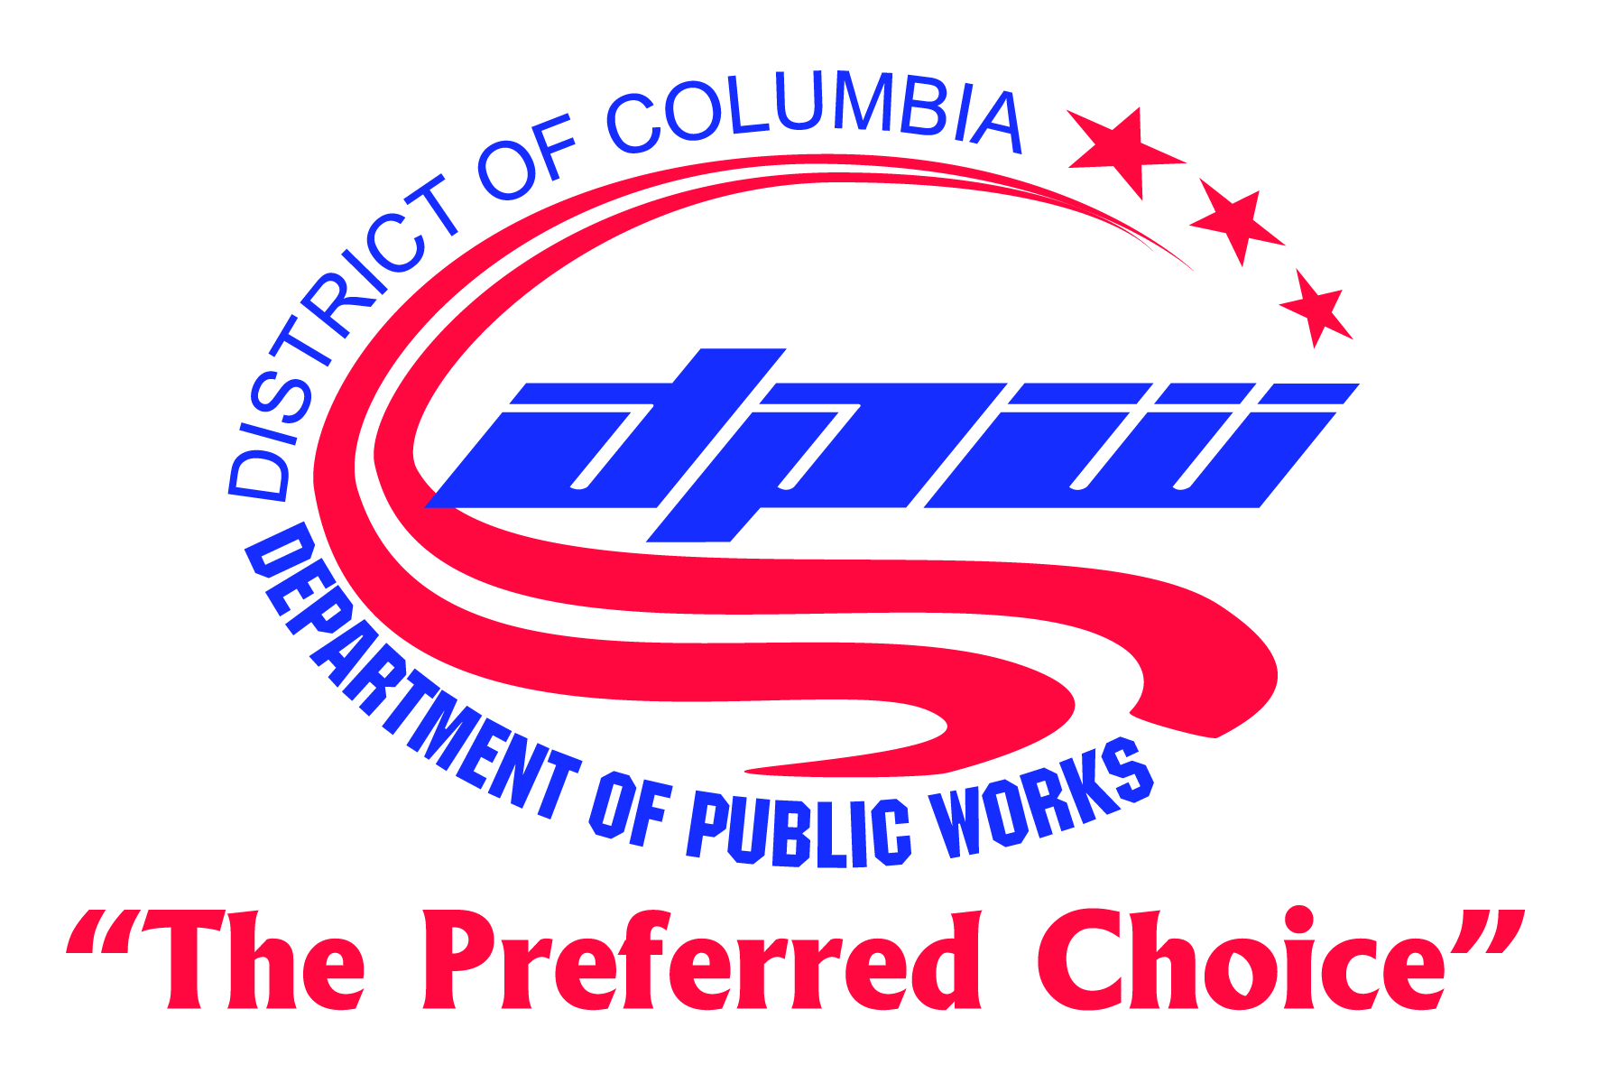

NEWS RELEASE NEWS RELEASE NEWS RELEASE
FOR IMMEDIATE RELEASE CONTACT: LINDA GRANT
Tuesday, February 11, 2014 202.671.2375

DPW TO OBSERVE PRESIDENTS DAY, MON., FEB. 17
Sanitation and parking enforcement services to be suspended that day.

(Washington, DC) The DC Department of Public Works announced today how services will be affected Presidents Day, Monday, February 17, when the District observes the holiday. Trash and recycling collections and parking enforcement will be suspended. All services will resume Tuesday, February 18.

While most DPW sanitation services will be suspended for the holiday, DPW will continue to deliver new Supercans and recycling cans to residents whose trash and recycling are collected by DPW. For more information go to Supercan, Trash Can and Recycling Can Frequently Asked Questions. Delivery of these new cans began Monday, February 10 in Ward 8 and will continue throughout the city following this schedule:
- Households with once-a-week trash and recycling collection will receive their new containers first.
- DPW will first deliver new cans to households where trash and recycling are collected on Friday (Wards 7 and 8).
- After, new cans have been delivered to all households with Friday collection, DPW will then deliver to households where trash and recycling are collected on Thursday (most of Ward 3).
- Next will come delivery to Wednesday collections households (parts of Wards 4 and 5).
- Then Tuesday collection households (the rest of Ward 5 and Ward 7).
- And finally Monday collection households (the rest of Ward 3 and Ward 4).
- After all households with once-a-week collection have received new cans, DPW will then begin delivering new cans to households with twice-a-week trash collection (mostly in Wards 1, 2, and 6). These households will receive new trash cans that are the same size as the cans they currently have along with 50% larger recycling cans.
Trash/recycling collections: Trash and recycling collections in once-a-week collection neighborhoods will “slide” to the next day for the remainder of the week. In neighborhoods with twice-weekly trash collections, Monday and Thursday collections will be made Tuesday and Friday, and Tuesday and Friday collections will be made Wednesday and Saturday.

Ft. Totten: Ft. Totten Transfer Station, located at 4900 John F. McCormack Drive, NE, will be closed to the public February 17. It will reopen Tuesday, February 18. Residents may bring trash and bulk items between 1 pm and 5 pm. The next Saturday household hazardous waste/e-cycling/document shredding drop-off day is March 1, 8 am to 3 pm, (these services are available the first Saturday of the month, except holidays).

To accommodate residents whose religious beliefs prohibit them from using the Saturday drop-off, DPW accepts household hazardous waste and e-cyclables only the Thursday before the first Saturday of the month (February 27, from 1 pm to 5 pm). DPW will not accept personal documents for shredding on Thursdays because they cannot be secured until the contractor arrives on Saturday.

Directions to Ft. Totten: Travel east on Irving Street, NW, turn left on Michigan Avenue, turn left on John F. McCormack Drive, NE and continue to the end of the street. Directions from additional locations can be found at http://dpw.dc.gov/node/414922.

Parking Enforcement: DPW will suspend enforcement of parking meters, residential parking, and rush hour lane restrictions on Presidents Day. DPW also will suspend towing abandoned vehicles. Enforcement resumes Tuesday, February 18.

# # #
